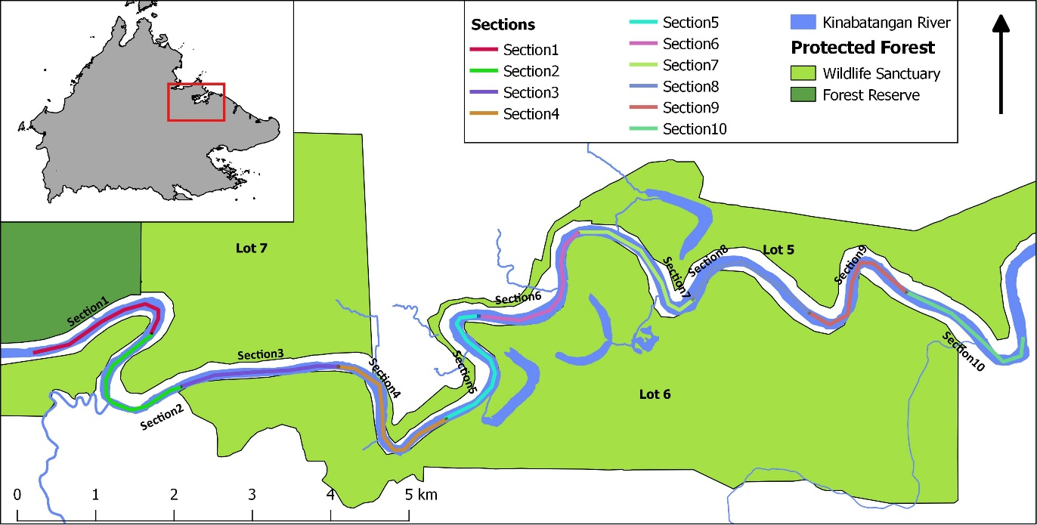
Figure 1. Study site. The inset map shows the location of the study site within Sabah (red rectangle). The Lower Kinabatangan region and the ten sections along the Kinabatangan River that were scanned in this study.

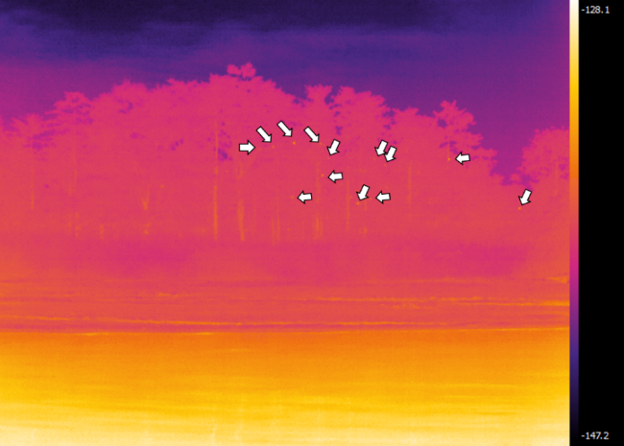
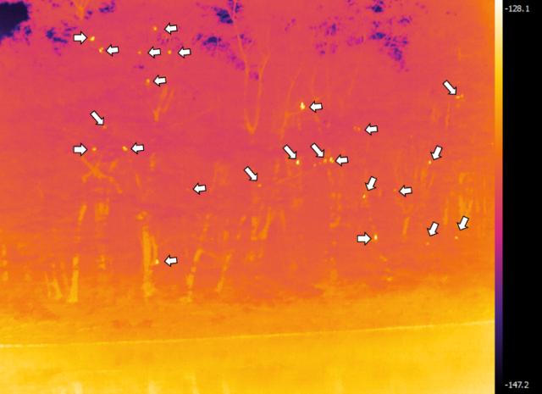
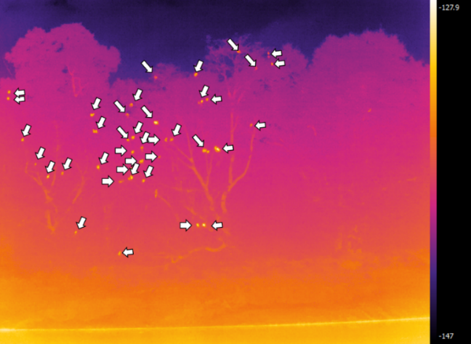
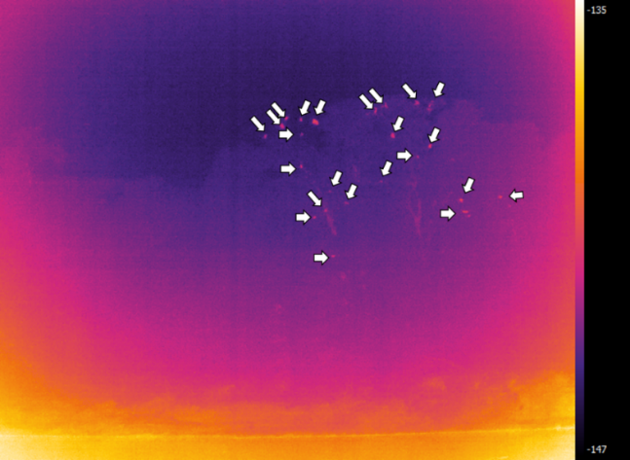
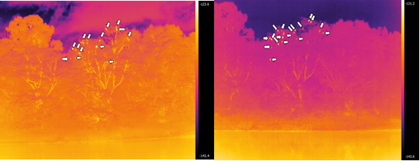
A1
A2
B1
B2
C1
C2
Figure 2. Thermal camera images taken under different conditions. The white arrows mark the dots that represented the primates counted. Different times of the day: A1) 5.00 pm; A2) 5.00 am, the thermal signal is clearer at this time of the day. Different distance from the observer to the trees, both images were taken at 5.00 am to show the variation in the images: B1) more than 100 m results in unclear animal detection; B2) less than 50 m results in sections of the trees being cut out of the image. Different weather condition, both images taken at 5.00 am: C1) blurry images due to foggy conditions; C2) clear weather resulting in clear images.
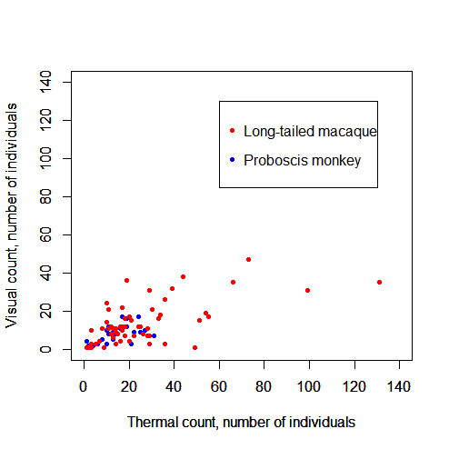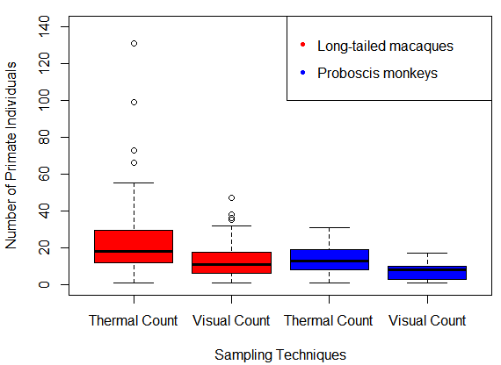
A
B
Figure 3. Higher numbers of primates are detected by the thermal count method. Red represents long-tailed macaques, and blue represents proboscis monkeys. A) Scatter plot shows the positive association between the thermal and visual survey techniques (r=0.72, p<0.001). B) Box plots indicate higher numbers of macaques and proboscis monkeys were able to be counted (solid black lines) with the thermal count technique than with than the visual count (Long tailed macaques: p<0.001; thermal n=1499, visual n=799. Proboscis monkeys: p=0.001; thermal n=388, visual n=223). The open circles in long-tailed macaque’s boxplots are outliers that indicate the value differs significantly from other observations (i.e. 1.5 standard deviations from interquartile range). The black line in the box is the median, and the horizontal line of the box indicate the upper and lower quartiles. The whiskers are the two lines outside the box that extend to the highest and lowest observations.
B

