Enhancing public health messaging: Discrete choice experiment evidence on the design of HIV testing messages in China

Maya Durvasula,^{1,2} Stephen W. Pan,^{2,3} Jason J. Ong,^{2,4} Weiming Tang,^{1,2} Bolin Cao,⁵ Chuncheng Liu,⁶ Fern Terris-Prestholt,⁷ Joseph D. Tucker^{1,2,4,8}

¹Institute of Global Health and Infectious Diseases, University of North Carolina at Chapel Hill, Chapel Hill, 27599, USA
²Social Entrepreneurship to Spur Health (SESH) Global, Guangzhou, 510095, China
³Department of Public Health, Xi’an Jiaotong-Liverpool University, Suzhou, 215123, China
⁴Faculty of Infectious and Tropical Diseases, London School of Hygiene and Tropical Medicine, London, WC1E 7HT, UK
⁵School of Mass Media and Communication, Shenzhen University, Shenzhen, 518060, China
⁶Department of Sociology, University of California San Diego, San Diego, CA, 92093, USA
⁷Department of Global Health and Development, London School of Hygiene and Tropical Medicine, London, WC1E 7HT, UK
⁸Dermatology Hospital, Southern Medical University, Guangzhou, 510095, China

Email addresses: maya.durvasula@gmail.com; stephen.w.pan@gmail.com; doctorjasonong@gmail.com; weimingtangscience@gmail.com; caobolin@szu.edu.cn; chchliu@ucsf.edu; Fern.Terris-Prestholt@lshtm.ac.uk; jdtucker@med.unc.edu

Word Count (including references, figures, tables): 8609

Corresponding author:
Joseph D. Tucker
2 Lujing Road
Dermatology Hospital, Southern Medical University
Guangzhou, China, 510095
Tel: +86 13560294997
Email: jdtucker@med.unc.edu

Acknowledgements:
We thank the Guangdong Provincial Dermatology Hospital’s Work-in-Progress seminar for helpful feedback. Special thanks to Siyan Meng for facilitating focus groups and interviews during the formative stages of this project. We are also grateful for funding support from the US National Institutes of Allergy and Infectious Diseases (NIAD1R01AI114310), Fogarty International Center (1D43TW009532), and the Robertson Scholars Program.

Declarations of Interest:
The authors declare no conflicts of interest.

Author Contributions:
Conceived, designed and tested the DCE: MD SWP JO WT CL FTP JDT. Led fieldwork: MD CL SWP WT. Analyzed the data: MD SWP. Wrote and revised the manuscript: MD SWP JO WT CL FTP JDT.
Enhancing public health messaging: Discrete choice experiment evidence on the design of HIV testing messages in China

Abstract
Introduction While a growing literature documents the effectiveness of public health messaging on social media, our understanding of the factors that encourage individuals to engage with and share messages is limited. In the context of HIV among men who have sex with men (MSM) in China, rising incidence and low testing rates despite decades of interventions suggest the need for effective, targeted messaging to reach underserved populations. Social media platforms and sex-seeking apps present a promising avenue, as web-based strategies can take advantage of existing trust within dense social networks. Methods We conducted an online discrete choice experiment in January 2017 with MSM from across China. Participants were presented with six choice tasks, each composed of two messages about HIV testing, and were asked in which scenario they were more likely to share the content. Participants were given information about the source of the HIV testing message, the social media sharing platform, and the recipients with whom they would share the message. They were given the option of sharing one message or neither. Multinomial and mixed logit models were used to model preferences within four subgroups. Results 885 MSM joined the survey, completing 4387 choice tasks. The most important attribute for three of the four subgroups was social media sharing platform. Men were more willing to share messages on sex-seeking mobile applications and less willing to share materials on generic (non-MSM) social media platforms. We found that men with more active online presences were less willing to share HIV testing messages on generic social media platforms. Conclusions Our findings suggest that sex-seeking platforms represent a targeted, efficient method of actively engaging MSM in public health interventions.

Keywords: HIV, HIV Testing, Discrete Choice Experiments, Men who have sex with men (MSM), China

Introduction
As rates of social media usage have increased and the costs of online communication have fallen, public health practitioners have come to share a holy grail with profit-driven digital marketers: a “viral” campaign, which is compelling enough to spread rapidly through networks and translate online engagement into offline behavior. Public health campaigns increasingly integrate online, popular components into interventions. For example, many interventions upload HIV messages onto social media with the goal of rapid forwarding and community-wide dissemination [1-3].

Similarly innovative approaches to increase HIV testing among MSM are needed. Despite efforts to improve HIV communication, there remains a high incidence of HIV and sexually transmitted infections (STIs) among men who have sex with men (MSM) in China [4]. A 2016 nationwide, cross-sectional study indicated that only 54% of MSM had ever been tested for HIV [5]. One study found that MSM with small social networks were themselves less likely to get tested [6]. Given that 92% of individuals in China between ages 18 and 29 have access to a smartphone and that rates of population-level online engagement continue to rise, online social networks provide strong platforms for public health campaigns [7]. Many studies demonstrate that MSM are most likely to meet new sexual partners online through sex-seeking mobile phone applications [8]. Data from China suggests that MSM who forward HIV testing messages are more likely to receive HIV testing [9]. Online interventions that widely disseminate through networks may also inspire greater trust [10].

However, while there is much literature on social media campaigns generally and HIV testing ones specifically, information about factors that contribute to wide dissemination of information in these settings is limited [11-14]. The Shannon-Weaver Model suggests three factors that influence the effectiveness of a public health messaging campaign: the source of messages, the platforms on which messages are distributed, and the target audience of a message [16]. These three factors can increase the likelihood of message transmission within and between online social networks.

In this study, we conducted a discrete choice experiment (DCE) to determine which aspects of HIV testing marketing impact MSM willingness to share specific HIV testing messages on social media platforms. We identify sets of message attributes that are likely to impact this sharing decision for distinct MSM subgroups, subdivided based on education and sexual history disclosure to medical professionals; quantify the relative influence of each attribute on sharing decisions; and identify individual characteristics that predict engagement with message sharing campaigns. Results from this work address the gap in HIV communication literature by beginning to identify specific components of public health messaging toward which distinct subgroups of MSM are receptive. Our findings provide key insights into specific campaign design features for public health practitioners who design online campaigns targeted to MSM in China.

Methods

Framework: Discrete Choice Experiments (DCEs)

DCEs are a stated preference method that provides quantitative estimates of the relative importance of the attributes that compose a single product or service [32]. DCEs differentiate services into constituent pieces, or attributes, in order to analyze preferences related to key attributes. Participants are presented with a choice task, which asks them to select between several service alternatives, often including an opt-out.

DCEs are typically formulated using the results of qualitative research, which inform the design of the choice task framework and survey instrument design [33]. The iterative construction of the choice task allows for integration of behavioral insights about a target population; when combined with the econometric advantages of this technique, DCEs offer three key advantages, compared to other approaches. First, researchers can quantitatively estimate the decision-making trade-offs and heuristics used when individuals make discrete choices. Second, by inferring individual preferences for stated choices in a series of scenarios, DCE estimates are less subject to the biases that alter individual reports of the motivations that drive their decisions [32]. Third, by presenting each individual with multiple hypothetical choice scenarios, DCEs provide a relatively cost-effective strategy to generate behavioral data in policy settings [15].
|

Communications Model

To consider the dissemination of messages shared on social media, we divided the process of receiving and engaging with an online message into its constituent parts.
The choice task was focused on willingness to share an online message. Messages were advertisements with pictures and text encouraging HIV testing. Social media platforms were broadly defined to include any online platform which allowed individuals to receive and share content with both individuals and groups. In this context, sharing was related to the platform. For example, sharing on a dating app might include either including a photo on one’s profile or explicitly sending the message to another person.

Given a choice between two scenarios that included message source, social media sharing platform, and message recipients, participants were asked in which scenario they were more likely to share the message. The message source referred to the person who most recently shared the message and included friends, sex partners, and medical professionals. Participants were given the option to share the message on a generic (non-MSM) social media platform, a sex-seeking app, or an MSM-focused message board. Additionally, the scenario included varied networks of message recipients, ranging from a small handful of friends to an entire network. Scenario attributes were chosen to represent all aspects of a message, including the message itself, that are likely to impact decisions about whether to share it on a particular social media platform.

This interpretation of public health advertising is consistent with formal theories of information and communication. In particular, this DCE takes its foundation from a version of the Shannon-Weaver model of communication and assumes that sharing decisions are impacted by factors like message source, message, and channel [16]. The stylized Shannon-Weaver model is included in Figure 1:

[Figure 1]

For online health messages, message source refers to the original author of the message (e.g., a non-governmental or public health organization). The transmitter is the online source of the message, which can include formal health organizations, medical professionals, friends, etc. Noise source captures the crucial introduction of additional content in online settings, including comments and captions that may alter an original message and other content. The DCE choice task is framed as the decision about whether they would hypothetically share the original message with another party.

DCE Development

The choice scenario structure of this DCE was developed using the findings from a four-month, iterative qualitative phase, which included: a review of existing literature; design and selection of HIV advertising materials; focus group discussions; and pre- and pilot testing of the survey instrument, including cognitive interviews with participants. This formative work was intended to inform the design of the choice tasks, including attribute and level selection as well as their pictorial representations.

Potential attributes were identified following a review of relevant literature, in consultation with experts on HIV in China’s MSM population. Focus groups were semi-structured and led by a study researcher. Focus group discussions included a guided discussion on current challenges associated with HIV testing for MSM in China, including issues with testing protocols and dissemination of information about testing, and unstructured feedback about proposed choice experiment attributes. When a pilot survey instrument had been compiled, with modifications included based on focus group participant feedback, cognitive interviews were conducted with pilot test participants. Survey respondents completed the DCE tasks while narrating their decision-making aloud to a study team member and provided feedback on the length and content of the questionnaire. While these responses were used to inform final modifications to the survey instrument, they were not included in the pilot data, given the high likelihood of desirability bias influencing responses given in the presence of a survey team member.

Message Selection

To assess factors that impact the virality of HIV testing messages, we used HIV testing messages from two sources: conventional HIV testing posters disseminated by provincial health authorities in China and crowdsourced messages. Crowdsourced messages were submitted in response to an open call for HIV testing messages organized by Social Entrepreneurship to Spur Health (SESH). During this contest, 88 MSM judges voted on their favorite messages, selecting from a total of 118 submissions [34].

We used SESH data on the judges’ socio-demographic characteristics and message preferences to select the messages for inclusion in this DCE. The widest variation in contest scores was observed between judges with different levels of education and different disclosure of sexual history to healthcare providers. Messages with the highest score for a particular group of judges (e.g. men without a college degree, men who never disclosed their sexual histories to a healthcare provider) were identified as the favorite contest message for a given subgroup. The overall crowd favorite message, with the highest rankings from judges across all groups, was also identified.

Six messages were included in the study materials: one traditional message and five crowdsourced messages. An HIV testing poster produced by the Center for Disease Control in the City of Jiangmen (Guangdong Province), intended for mass dissemination, was included as the traditional message.

[FIGURE 2]

All participants were shown the traditional and crowd favorite messages. Because the widest variation in contest scores was identified between judges with different levels of education and different disclosure of sexual histories to healthcare providers, we selected different DCE messages for high and low education individuals and for individuals with different disclosure of their sexual histories to healthcare providers. However, because the crowd-judging process focused on message content and quality, rather than virality, we do not attempt to pool results or compare preferences across different subgroups, as respondents were presented with tailored messages only. Thus, all analyses in this paper are stratified, with separate results reported for four subgroups: a. high education/no disclosure; b. low education/ no disclosure; c. high education/disclosure; and d. low education/ disclosure.

Attributes and Levels
To select the remaining attributes, we conducted five focus groups with a total of 24 MSM living in Guangzhou, the most populous city in Guangdong Province. Eligible participants were at least 16 years old, born biologically male, and had ever engaged in anal or oral sex with a man. Written informed consent was obtained from all participants.

Focus group discussion guides were iteratively revised, based on findings from all preceding discussions. The discussion leader encouraged participants to discuss their exposure to public health messaging in both on and offline settings. These discussions were intended to determine which aspects of public health message dissemination impacted message credibility and which factors might influence decisions to “like” and “share” messages on various social media platforms.

Focus group discussions suggested that three primary factors influenced an individual’s decision about whether to engage with advertising content, in addition to the message itself: the source of the message, which influenced its perceived credibility; the platform on which the content was presented, which influenced both credibility and the social consequences of sharing; and the recipients of any shared message, which dictated the potential social costs and stigma associated with sharing. Based on the first three focus groups, these three attributes were selected in addition to the messages themselves: message source, social media platform for message sharing, and recipients of shared message (Figure 3). Pictorial representations and Chinese text were refined in the remaining two focus group discussions. Transcripts from focus group discussions were analyzed using content analysis strategies in NVivo software (QSR International 2015) to identify recurring trends and themes in discussions.

In addition to this DCE, the survey instrument included four sections on socio-demographic characteristics, HIV testing preferences, social networks, and partner services. It also included a section on general online behaviors, which allowed subsequent analyses to consider whether men who opted out of choice tasks – choosing neither option – were rejecting a specific scenario or whether they remain passive consumers of information (maintaining a presence without actively liking, sharing, or posting) on social media [17].

The survey instrument was pre-tested with 25 MSM, including 15 in-person pre-test interviews conducted in Guangzhou. Each in-person participant completed an online survey while narrating his decision-making for an interviewer, who then conducted a 15-minute debriefing interview [18]. Based on participant feedback, Chinese text and pictorial representations were finalized. An example choice set is included in Figure 4.

Experimental Design

For any individual, there are 108 unique message-sharing scenarios, with 5778 possible binary choice sets. There are no established guidelines that identify the optimal number of DCE choice tasks per respondent, though a review of 79 conjoint analyses related to health reported that the majority of studies present between seven and 15 tasks to each respondent [19-21]. As this DCE followed a related DCE on HIV testing attributes in a single survey instrument, we chose to limit each respondent to six tasks in each experiment.

We used NGene software (ChoiceMetrics 2014) to generate a D-efficient statistical design, with six blocks of six choice tasks per block. To improve the precision of parameter estimates, the design produced in NGene used prior parameter estimates from an online pilot test of 96 self-identified MSM in China; these responses were not included in the final survey sample.

In keeping with current DCE best practices, the blocked D-efficient design allows participants to consider only a fraction of total possible choice tasks to promote response efficiency and reduce cognitive burden [15]. Participants were randomly assigned to one of the six blocks upon meeting the survey’s eligibility criteria; each completed a maximum of six tasks. Block randomization and choice scenario design were also completed in NGene [22]. The attribute order (message, source, medium, recipients) was structured to mimic the order of decision-making when individuals share messages online and encourage sequential consideration.

Sample/Data Collection

An online survey, open across China, was conducted during January 2017. Messages were placed on two popular MSM social networking platforms and community based organization websites. Eligible participants were at least 16 years old, were born biologically male, and had ever engaged in anal or oral sex with a man. Individuals who completed the survey in its entirety received 50 RMB in phone credits (~7.5 USD, as of January 2017).

An analysis of the generalizability of online survey samples in China indicates that online respondents tend to be younger and better educated than the larger population of interest [23]. To address this issue, sampling quotas were included in the survey instrument that ensured 50/50 representation of each of the following categories: income (above/below 3000 RMB per month), education (above/below high school), and disclosure of MSM history to a healthcare worker (yes/no). As the analysis in this paper focuses entirely on preferences within subgroups, rather than preferences within the MSM population at-large, we did not pool or re-weight the sample.

Minimum sample size was determined using the rule of thumb proposed by Johnson and Orme [37], who suggest that the sample size depends on the number of choice tasks (t), number of alternatives (a), and number of analysis cells/maximum number of levels of a given attribute (c), according to the following equation:
N > 500c/(t * a)
With t = 6 (i.e. six choice tasks per respondent), a = 2 (i.e. two alternatives), and c = 4 (maximum number of levels per attribute), N > 167 is sufficient per subgroup. As the analysis in this paper is stratified for four subgroups, a minimum total sample size of 668 is necessary.

Econometric Model

A random utility framework underlies the analysis of choice experiments and indicates that an individual i derives utility from alternative j in choice task t according to the following:

U_{ijt} – X’_{ijt}β ; i = 1, … , N; j = 1, … J ; t = 1, … T

where X’_{ijt} is a vector of message attributes and individual socio-demographic characteristics associated with individual i, while β is a vector of coefficients to be estimated.

In this analysis, we use both the MNL and the mixed logit (ML), as the latter allows for the development of a more realistic model of decision-making. To identify the ways in which preferences vary by observable respondent characteristics, we also considered descriptive characteristics of respondent choice behavior, including patterns of opting out of choice tasks.

While the MNL is considered the workhorse for discrete choice analysis [32], it cannot account for unobserved heterogeneity in respondent preferences, nor can it represent more broadly any unobserved variability. Additionally, the MNL imposes the “independence of irrelevant alternatives” (IIA) assumption, which assumes that random errors are independent and can result in unrealistic model predictions. The ML relaxes the IIA restrictions, while capturing unobserved preference heterogeneity by allowing for random variation across individuals [24].

Standard output from a discrete choice model yields utilities associated with a particular attribute level. For all levels of included attributes (message, source, platform, recipient), we used effects coding (i.e. an unlabeled experiment). All coefficients, then, are interpreted as divergence in relative utility from a mean utility of zero. As all levels are categorical variables, the coefficient on the omitted attribute level is calculated as: [-1*Σ(all coefficients of other levels)] [15].

We estimate both a main effects model, which includes only levels of attributes, and versions of the model that include effects-coded interaction terms to capture heterogeneity in respondent preferences. Interaction terms were included based on hypothesized relationships with disclosure of MSM history to healthcare providers, education, age, community engagement, and social media use. Community engagement is an index that ranges from 0 to 5 and captures respondent answers to five questions about involvement with community events related to sexual health; a higher score indicates greater community engagement. Social media use is also an index that ranges from 0 to 6 and captures respondent usage of six types of social media platforms (WeChat, Weibo, QQ, blogs, message boards, dating apps); a score of 6 indicates that a respondent uses all platforms, while a score of 0 indicates no social media presence. Age is a binary variable, which splits respondents into younger and older bins at age 24, the sample median, to align with the age categories from quota sampling.

In accordance with standard reporting practices for DCEs, we calculated the relative influence of each attribute on choice tasks [25-27]. The proportional influence of each attribute was calculated by dividing the range of parameter estimates for a given attribute by the sum of all parameter estimate ranges for all attributes. The proportional influence for each attribute captures the proportion of DCE choices that were determined by the given attribute, excluding the influence of unobserved and unmeasured factors that appear in error terms. Proportional influence values were calculated for each of the four subgroups under consideration.

Estimation

All analyses were conducted in Stata 14.1 (StataCorp, College Station, TX), using the mlogit and mixlogit packages. The ML coefficients were estimated using 500 halton draws; all standard deviations were specified as normally distributed.

Ethics Statement
Approval was obtained for this study from Institutional Review Boards at the University of North Carolina at Chapel Hill (North Carolina, USA) and the Guangdong Provincial Dermatology Hospital (Guangzhou, China). Informed consent was obtained from each study participant for each phase.

RESULTS

Respondent Characteristics

From January 5 to January 29, 2017, the survey link was visited 3319 times. 854 eligible participants completed a total of 4387 choice tasks. More than half (57%, 505/885) of respondents completed all six choice tasks; 88% of participants (779/ 885) completed at least four choice tasks. Respondent characteristics are reported in Table 1.

Descriptive Choice Behavior

In 17% of all choice tasks, participants chose to opt out, selecting the option of sharing nothing instead of one of the two message sharing scenarios. Participants were unable to advance to the next scenario without making a selection. Seventy-one respondents (8%) chose to opt-out of every choice scenario. While the stratified nature of this analysis makes it difficult to compare frequencies between groups, high education individuals who had disclosed their sexual histories had the lowest opt-out rate (13%), while low education respondents who had not disclosed had the highest (18%).

We ran a series of MNL regressions for the full sample and for each subgroup to consider the likelihood of opting-out, based on the following characteristics: dating app usage, age, education, activity on social media (posting, commenting), and sexual history disclosure. Results are reported in the appendix for the full sample (n= 854).

To consider whether individuals who opted out of tasks did so in order to reach the end of the questionnaire more quickly, we compared average response times of respondents who opted out of tasks with those who did not. Notably, there was no statistically significant difference between the time it took those who opted out on every task to complete the survey and all other respondents’ times.

Individuals who never commented on social media were significantly more likely to opt out of choice tasks (OR = 1.23, 95% CI: 1.16 – 1.44), as were individuals who never post on social media (OR = 1.62, 95% CI: 1.15 – 2.18); notably, while never posting and never commenting on social media were correlated, the relationship (correlation coefficient = .29) is relatively weak. Individuals with more active social media presences were significantly less likely to share advertisements (OR = 0.89, 95% CI: 0.86 – 0.93), as were respondents with higher levels of community engagement (OR = 0.79, CI: 0.77 – 0.81) and respondents who had ever disclosed their sexual histories to medical providers (OR = 0.70, 95% CI: 0.64 – 0.75). There was no significant relationship between a respondent’s age and his likelihood of opting out of choice tasks.

These trends for the full sample are qualitatively similar to subgroup analyses. In particular, low education men who had never disclosed their sexual histories but who identify as gay were significantly more likely to opt-out of sharing (OR = 2.28, 95% CI: 1.80 – 2.89).

Econometric Modeling

Results from mixed logit regressions are reported in Table 2; results from analogous multinomial logistic regressions are reported in the Appendix. The coefficient magnitude captures the relative utility associated with a particular attribute level. Signs on coefficients indicate whether inclusion of a level increases (positive) or decreases (negative) the probability of selection. The utility of each scenario is estimated as the sum of its components (i.e. the sum of the level utilities).

Log likelihood values are reported for the multinomial (MNL) and mixed (ML) logit regressions and indicate better model fit for the ML model for all four subgroups. Significant standard deviation terms for ML specifications suggest the existence of unobserved heterogeneity that is not captured in the MNL models for message and message source specifically.

Across all four groups and specifications of the model, respondents preferred the crowd favorite message, preferred not to share HIV messages originally shared by friends, and strongly preferred to share messages on MSM sex-seeking apps, rather than on generic social media platforms. Similarly, all four groups preferred to share messages with smaller networks, rather than their entire set of connections.

Notably, men with at least a high school education who had disclosed their sexual histories to medical providers had fewer strong preferences for particular advertising components than men in other subgroups. Older men in this group (above age 24) were more likely to share messages provided by medical professionals (β = .306, SE = .150), and men with higher levels of community engagement were more likely to share messages originally shared by friends (β = .092, SE = .047).

Among men with at least a high school education who had not disclosed their sexual histories to medical providers, there was a strong preference against sharing a message that was initially shared by a friend (β = -.706, SE = .307), though this negative preference was slightly weaker for older men (β = .311, SE = .178). Older men, in contrast, were less willing to share messages that originated with medical providers (β = -.281, SE = .170). Within this group, high levels of social media use are associated with a increased willingness to share messages on sex-seeking apps (β = .129, SE = .077) and a decreased willingness to share on generic social media platforms (β = -.147, SE = .078),

Men with low education, defined as high school and below, who had disclosed their sexual histories to medical providers strongly preferred to share messages provided by medical professionals (β = .496, SE = .293) over messages initially shared by friends (β = -.628, SE = .287). Men over age 24 were significantly more willing to share a message on a generic social media platform (β = .467, SE = .204), in contrast to other categories of respondents.

Respondents with less than a high school education who had not disclosed their sexual histories to medical providers expressed the strongest relative preference for sharing messages on sex-seeking apps (β = .753, SE = .235).

Relative Influence of Attributes

Table 3 reports the relative influences of the four message attributes, stratified by subgroup, and relative values are graphically represented in Figure 5. Values can be interpreted as an average estimate of the proportional influence of a given attribute on the decision to share, reported for each subgroup. For high education respondents, as well as low education men who had not disclosed their sexual histories, the platform on which messages are sent and received had the most substantial impact on decision-making. For high education men who had disclosed their sexual histories, platform was twice as impactful as the network of message recipients, and more than twice as impactful as either the message itself or the message’s source. Message as an attribute had a stronger relative importance for the other three subgroups and was the most important factor for low education men who had disclosed their sexual histories. For all four subgroups, message source was the least important attribute.
[FIGURE 5]

Discussion & Implications for Policy Design

With public health interventions increasingly incorporating online components, the successes of marketing campaigns and accompanied shifts in behavior rely on the identification of factors that enable messages to go viral. Our study sought to identify those aspects of HIV test messaging that increase the likelihood that an MSM shares a message with friends in the Chinese context. In order to identify factors that may impact the success of a messaging campaign, we also considered individual characteristics that are likely to impact decisions about message sharing online. This approach extends the literature on public health messaging and HIV test promotion by considering online sharing as the behavior of interest and quantifying preferences over online advertising components of a campaign. Additionally, this study identifies heterogeneity in subgroup preferences over various aspects of online behavior. Findings are instructive for governments and public health practitioners who intend to design online campaigns to promote HIV testing.

We found that men in all subgroups were most willing to share messages with their networks on sex-seeking apps. This finding is consistent with evidence on the feasibility and acceptability of sexual network apps as platforms for public health messaging [28]. Cross-sectional data from app-based interventions suggests that these HIV testing messages are correlated with HIV testing [29]. The willingness across subgroups to engage with messages on sex-seeking apps is encouraging for subsequent intervention development, though the potential logistical difficulties of accessing sex-seeking platforms for public health purposes are worth noting. The MSM sex-seeking app may facilitate norms and expectations of behavior that make it more likely to share messages. In particular, the likelihood of inadvertently disclosing one’s MSM behaviors by sharing an HIV testing message is decreased within MSM apps.

Additionally, we found that men with more active online presences were less willing to share HIV messages on generic (non-MSM) social media platforms. This similarly suggests that fear of MSM disclosure or stigma associated with HIV may impact online engagement with testing materials. This is consistent with literature on prejudice, stigma, and social discrimination as barriers to HIV prevention in China [30]. These findings about social media use and network size suggest that existing trust between users on generic platforms may not be sufficient to encourage widespread dissemination of messages.

We identified an MSM subgroup who were less likely to engage with online messaging and more likely to opt out of choice tasks. Men who opted out were younger, less educated, less likely to use dating apps, and less likely to have disclosed sexual history. This profile of individuals who choose not to engage with these types of interventions is consistent with descriptive characteristics of higher-risk, underserved MSM populations [10, 31]. A more detailed understanding of this group is necessary for many public health interventions, which seek to translate active online engagement with content into offline behavior shifts. These findings suggest that, although targeted online messaging may succeed in engaging certain key populations, individuals who are not receptive to campaigns are systematically different, in terms of risk characteristics, than other recipient groups. HIV testing campaigns must work to integrate alternative strategies for individuals who fall into these categories, who are less likely to engage with online messages distributed through any channels, by providing support for in-person, network-based intervention strategies.

Several limitations to this study should be noted. First, all formative work was conducted in South China. Although findings from focus group discussions and pilot tests were checked against existing literature, focus group participants played a sizable role in determining the structure of the final choice experiment. These opinions may not be generalizable, both in other geographies and among individuals who do not voluntarily participate in focus groups. Particularly in regard to HIV messaging, evidence suggests some alignment between stated and revealed preferences [29]; however, external validity is a broader, unavoidable challenge for any stated choice analysis. In particular, the emphasis on the Chinese context in the design of the experiments means that one should be cautious when attempting to infer conclusions about behavior in settings other than China. Participants expressed preferences about intent to share messages; further work should consider the relationship between stated preferences and revealed preferences in field experiments that track actual online sharing behavior and associated offline testing behaviors. Second, as findings are applicable to specific subgroups, our findings should be interpreted carefully. We were unable to pool results for the full sample of respondents because of the study design. MSM subgroups viewed different sets of tailored messages based on their socio-demographic characteristics. Finally, it is important to note that this experiment was conducted using a non-representative sample of MSM, who were recruited through online MSM-focused social media platforms and community based organization websites. Although this group is a likely audience for public health interventions that would utilize similar platforms, it is not representative of online MSM or all MSM in China. Further work should consider replicating similar experiments with population-representative samples.

Conclusions

To address rising rates of HIV infection and the widespread lack of awareness about HIV among individuals in marginalized communities, more innovative strategies that take advantage of online platforms and networks are needed. MSM in higher risk groups are particularly vulnerable to HIV infection if their access to public health information from social networks is limited [10]. This is particularly important in China, where high HIV incidence and entrenched stigmas limit individual willingness both to engage with public health campaigns and get tested for HIV [30, 37]. For a range of key subgroups, the platform on which HIV test messages are disseminated is crucial in determining the virality of a health communication campaign. Public health practitioners should consider carefully the platforms that are used to spread information, while continuing to seek innovative strategies to engage higher-risk individuals who are not receptive to online campaigns.

REFERENCES

[1] Ramallo J, Kidder T, Albritton T, Blick G, Pachankis J, Grandeleski V, et al. (2015). Exploring social networking technologies as tools for HIV prevention for men who have sex with men. AIDS Educ Prev. 27(4):298–311.

[2] Young SD, Szekeres G, Coates T. (2013). The relationship between online social networking and sexual risk behaviors among men who have sex with men (MSM). PLoS One;8(5): e62271. PMID: 23658716

[3] Tso LS, Tang W, Li H, Yan HY, Tucker JD. (2015). Social media interventions to prevent HIV: A review of interventions and methodological considerations. Curr Opin Psychol; 9:6–10. PMID: 26516632

[4] Bien CH, Best JM, Muessig KE, Wei C, Han L, Tucker JD. (2015). Gay apps for seeking sex partners in China: Implications for MSM sexual health. AIDS Behav;19(6):941–946. PMID: 25572834

[5] Zhang TP, Liu C, Han L, Tang W, Mao J, Wong T, Zhang Y, Tang S, Yang B, Wei C, Tucker JD. (2017). Community engagement in sexual health and uptake of HIV testing and syphilis testing among MSM in China: a cross-sectional online survey. Journal of the International AIDS Society. 20(1):21372.

[6] Huang ZJ, He N, Nehl EJ, Zheng T, Smith BD, Zhang J, McNabb S, Wong FY (2012). Social Network and other correlates of HIV testing: findings from male sex workers and other MSM in Shanghai, China. Aids Behav; 16(4):858-71.

[7] Telefonica: Index on Digital Life. (2014). “Millennials Become the Smartphone Generation.”

[8] Wu Z, Xu J, Liu E, et al. (2013). HIV and Syphilis Prevalence Among Men Who Have Sex With Men: A Cross-Sectional Survey of 61 Cities in China. Clinical Infectious Diseases;57:298–309.

[9] Cao B, Liu C, Durvasula M, Tang W, Saffer AJ, Wei C, Tucker JD. (2017). Social Media Engagement and HIV Testing Among Men Who Have Sex With Men in China. Journal of Medical Internet Research, 19(7): e251.

[10] Huang ZJ, He N, Nehl EJ, Zheng T, Smith BD, Zhang J, McNabb S, Wong FY (2012). Social Network and other correlates of HIV testing: findings from male sex workers and other MSM in Shanghai, China. Aids Behav; 16(4):858-71.

[11] Tucker JD, Cao B, Li H, Tang S, Tang W, Wong NS, et al. (2016). Social media interventions to promote HIV testing. Clin Infect Dis; 63(2):282–3.

[12] Heldman AB, Schindelar J, Weaver JB. (2013).Social media engagement and public health communication: Implications for public health organizations being truly “social.” Public Health Rev;35(1):1–18.

[13] Chou WS, Hunt YM, Beckjord EB, Moser RP, Hesse BW. (2009). Social media use in the United States: implications for health communication. J Med Internet Res; 11(4): e48.

[14] Carrotte ER, Vella AM, Lim MS. (2015). Predictors of “Liking” three types of health and fitness-related content on social media: A cross-sectional study. J Med Internet Res; 17(8): e205.

[15] Hensher, David A., et al. Applied Choice Analysis. (2015). Cambridge University Press.

[16] Shannon CE (1948). A Mathematical Theory of Communication, The Bell System Technical Journal. 27, 379-423, 623-656.

[17] Bolton RN, A. Parasuraman, Ankie Hoefnagels, Nanne Migchels, Sertan Kabadayi, Thorsten Gruber, Yuliya Komarova Loureiro, David Solnet. (2013) "Understanding Generation Y and their use of social media: a review and research agenda", Journal of Service Management. 24 (3) 245-267, https://doi.org/10.1108/09564231311326987

[18] Ryan M., Watson V, Entwistle V. (2008). “Rationalising the ‘irrational’: a think aloud study of discrete choice experiment responses,” Health Economics, Vol 18, Issue: 3, pp. 321-336.

[19] Green C. Justice, fairness, and equity in health care: exploring the social value of health care interventions. (2007). PhD Thesis. University of Southampton, Southampton.

[20] Greiner R, Bliemer M, Ballweg J. (2015). Design considerations of a choice experiment to estimate likely participation by north Australian pastoralists in contractual biodiversity conservation. Journal of Choice Modeling. 10:34-45.

[21] Louviere JT, Islam T, Wasi N, Street D, Burgess L. (2008). Discrete Choice Experiments: Do Optimal Designs Come at a Price? Journal of Consumer Research. 35(2):360-375.

[22] ChoiceMetrics. Ngene 1.1.2 User Manual & Reference Guide [Internet]. ChoiceMetrics; 2014. Available from: https://dl.dropboxusercontent.com/u/9406880/NgeneManual112.pdf

[23] Cheng W, Mollan KR, Hudgens MG, Tucker JR, Zheng H, Tang W and Ling L.
Generalizability of an Online Randomized Controlled Trial: an Empirical Analysis. Journal of Epidemiology and Community Health. 72:173-178.

[24] Ryan et al, Ed. Using Discrete Choice Experiments to Value Health and Health Care. (2008).
[25] Czoli CD, Goniewicz, M., Islam, T., Kotnowski, K., & Hammond, D. (2015). Consumer preferences for electronic cigarettes: results from a discrete choice experiment. Tobacco Control, 25, e30-6.
[26] Hauber, AB, Arden, NK, Mohamed, AF, Johnson, FR, Peloso, PM, Watson, DJ, Taylor, SD (2013). A discrete-choice experiment of United Kingdom patients ’ willingness to risk adverse events for improved function and pain control in osteoarthritis. Osteoarthritis and Cartilage, 21(2), 289–297.

[27] Hauber, A. B., González, J. M., Groothuis-oudshoorn, C. G. M., Prior, T., Marshall, D. A., Cunningham, C., … Bridges, J. F. P. (2016). Statistical Methods for the Analysis of Discrete Choice Experiments : A Report of the ISPOR Conjoint Analysis Good Research Practices Task Force. Value in Health, 19(6), 300–315.

[28] Sun CJ, Stowers J, Miller C, Bachmann LH, Rhodes SD. (2015) Acceptability and feasibility of using established geosocial and sexual networking mobile applications to promote HIV and STD testing among men who have sex with men. AIDS Behav; 19(3): 543-52.

[29] E Huang, Marlin RW, Young SD, Medline A, Klausner JD. (2014) “Using Grindr, a smartphone social-networking application, to increase HIV self-testing among black and latino men who have sex with men in Los Angeles,” Aids Educ Prev, 28(4):341-350.

[30] Tang W, Mahaptra T, Tucker JD, Zhao J, Detels R. (2014). Prejudice, Stigma, and Social Discrimination: Perceived Barriers in HIV Prevention and Control among Men Who Have Sex with Men in China. J Clin Case Rep 4:448.

[31] Bai X, Xu J, Yang J, Yang B, Yu M, Gao Y, Dong W, Wu Z. (2014). HIV prevalence and high-risk sexual behaviors among MSM repeat and first-time testers in China: implications for HIV prevention. J of International AIDS Society. 17: 18848.

[32] De Bekker-Grob EW, Hol L, Donkers B, et al. (2010). Labeled versus unlabeled discrete choice experiments in health economics: An application to colorectal cancer screening. Value in Health. 13: 315–323.

[33] Coast, J., Al Janabi, H., Sutton, E. J., Horrocks, S. A., Vosper, A. J., Swancutt, D. R., et al. (2011). Using qualitative methods for attribute development for discrete choice experiments: issues and recommendations. Health Economics. 21:730-741.

[34] Tang W, Wei C, Cao B, Wu D, Li KT, Lu H, et al. (2018) Crowdsourcing to expand HIV testing among men who have sex with men in China: A closed cohort stepped wedge cluster randomized controlled trial. PLoS Med 15(8): e1002645. https://doi.org/10.1371/journal.pmed.1002645

[35] McFadden, D. (1974). Conditional logit analysis of qualitative choice behaviour. In P. Zarembka (Ed.), Frontiers in econometrics (pp. 105-142). New York: New York Academic Press.
[36] Pan, S.W., Durvasula, M., Ong, J.J., Liu, C., Tang, W., Fu, H., Wei, C., Wang, C., Terris-Prestholt, F., Tucker, J.D. (2018). No Place Like Home? Disentangling Preferences for HIV Testing Locations and Services Among Men Who Have Sex with Men in China. AIDS and Behavior, forthcoming.
[37] Johnson R., Orme B. Getting the most from CBC. Sequim: Sawtooth Software Research Paper Series, Sawtooth Software; 2003.

[38] Tucker JD, Day S, Tang W, Bayus B. 2018. Crowdsourcing in medical research: theory and practice. PeerJ Preprints 6:e27331v1

TABLES

Table 1: Summary Statistics, (Chinese MSM, n = 854)
 | Total (%)
Age
Under 24 | 443 (50)
Over 24 | 442 (50)
Educational Attainment
Elementary/Middle | 150 (17)
High school | 325 (37)
Vocational college | 149 (17)
Four year college and above | 261 (29)
Urban residency status
Offical urban resident | 466 (53)
Rural resident | 419 (47)
Current marital status
Single | 754 (85)
Married | 79 (9)
Separated/ divorced/widowed | 52 (6)
Sexual orientation
Gay | 701 (79)
Heterosexual | 152 (17)
Bisexual | 8 (1)
Unsure | 24 (3)
Income, USD/Month
< 217 | 192 (22)
217 - 433 | 274 (31)
434 - 724 | 265 (29)
725 - 1159 | 94 (11)
> 1159 | 60 (7)
Ever tested for HIV
Yes | 636 (72)
No | 249 (28)
Completion rates
6/6 choice sets | 504 (57)
4/6 choice sets | 779 (88)

Table 2: Mixed Logit, Results (Chinese MSM, n = 854)
 | No Interactions |  |  |  | Interactions
 | High ed, Disc. | High ed, No Disc. | Low ed, Disc | Low ed, No Disc | High ed, Disc. | High ed, No Disc. | Low ed, Disc | Low ed, No Disc
Coefficients
Log likelihood | -1136.36 | -1161.38 | -962.34 | -1030.74 | -1126.63 | -1152.71 | -948.91 | -1023.44
Opt out | -1.10*** | -.494*** | -.842*** | -.754*** | -1.105*** | -.491*** | -.839*** | -.753***
 | (.089) | (.078) | (.092) | (.085) | (.089) | (.079) | (.092) | (.086)
Message
CDC | -.079 | -.068 | .127 | .310*** | -.089 | -.067 | .121 | .310***
 | (.080) | (.080) | (.099) | (.089) | (.082) | (.081) | (.096) | (.090)
Crowd favorite | .111 | .390*** | .530*** | .412*** | .116 | .346*** | .537*** | .413***
 | (.091) | (.092) | (.098) | (.094) | (.093) | (.094) | (.100) | (.095)
Education message | -.028 | .107 | -.669*** | -.503*** | -.016 | .091 | -.681*** | -.500***
 | (.098) | (.100) | (.104) | (.101) | (.099) | (.102) | (.107) | (.103)
Disclosure message | -.004 | -.419*** | .012 | -.219** | -.011 | -.370*** | .023 | -.223**
 | (.073) | (.087) | (.101) | (.093) | (.090) | (.093) | (.098) | (.097)
Originator
Medical Professional | .029 | .119 | -.009 | .058 | .054 | .416 | .496* | -.018
 | (.075) | (.075) | (.086) | (.079) | (.273) | (.291) | (.283) | (.265)
Friend | -.084 | -.231*** | -.106 | -.100 | -.474 | -.706** | -.628** | -.237
 | (.085) | (.083) | (.092) | (.086) | (.298) | (.307) | (.287) | (.272)
Partner | .055 | .112** | .115* | .042 | .420 | .290 | .132 | .255
 | (.080) | (.078) | (.089) | (.083) | (.281) | (.295) | (.297) | (.270)
Medium
Social media (general) | -.382*** | -.318*** | -.090 | -.381*** | -.018 | .193 | -.229 | -.293
 | (.076) | (.081) | (.091) | (.082) | (.268) | (.300) | (.293) | (.255)
Sex-seeking apps (MSM) | .343*** | .421*** | .252*** | .418*** | .176 | -.154 | -.269 | .753***
 | (.068) | (.080) | (.084) | (.075) | (.232) | (.297) | (.252) | (.235)
Blogs | .039 | -.103 | -.162 | .037 | -.158 | -.039 | .498** | -.460*
 | (.072) | (.081) | (.087) | (.077) | (.253) | (.299) | (.260) | (.240)
Recipients
All | -.229*** | -.095 | -.198*** | -.343*** | .258 | -.294 | -.027 | -.254
 | (.082) | (.084) | (.092) | (.091) | (.300) | (.319) | (.299) | (.300)
Small networks (10-12 people) | .205*** | .087 | .093 | .376*** | .076 | .327 | -.245 | .289
 | (.077) | (.078) | (.092) | (.082) | (.280) | (.302) | (.291) | (.265)
Handful of friends (5-7 people) | .024 | .008 | .105 | -.033 | -.334 | -.033 | .272 | .035
 | (.079) | (.080) | (.090) | (.084) | (.291) | (.308) | (.293) | (.281)
Interactions: Recipients
All*Engagement |  |  |  |  | -.034 | .041 | -.010 | -.020
 |  |  |  |  | (.048) | (.054) | (.049) | (.061)
Network*Engagement |  |  |  |  | .030 | -.006 | .054 | .025
 |  |  |  |  | (.044) | (.050) | (.049) | (.054)
All*SocialMediaUse |  |  |  |  | -.100 | .030 | -.039 | -.059
 |  |  |  |  | (.066) | (.083) | (.082) | (.083)
Network*SocialMediaUse |  |  |  |  | .009 | -.073 | .109 | .028
 |  |  |  |  | (.062) | (.079) | (.078) | (.074)
All*Age |  |  |  |  | -.167 | .062 | -.049 | .213
 |  |  |  |  | (.163) | (.187) | (.207) | (.182)
Network*Age |  |  |  |  | -.001 | -.002 | -.225 | -.064
 |  |  |  |  | (.155) | (.178) | (.206) | (.162)
Interactions: Medium
SocialMedia*Engagement |  |  |  |  | -.091 | -.019 | .001 | -.055
 |  |  |  |  | (.059) | (.050) | (.048) | (.053)
App*Engagement |  |  |  |  | .018 | .036 | .087** | -.022
 |  |  |  |  | (.037) | (.049) | (.044) | (.047)
SocialMedia*SocialMediaUse |  |  |  |  | -.091 | -.147** | -.073 | -.008
 |  |  |  |  | (.059) | (.078) | (.079) | (.071)
App*SocialMediaUse |  |  |  |  | .049 | .129** | .138** | -.121
 |  |  |  |  | (.053) | (.077) | (.066) | (.065)
SocialMedia*Age |  |  |  |  | .002 | -.038 | .467** | .075
 |  |  |  |  | (.145) | (.175) | (.204) | (.159)
App*Age |  |  |  |  | -.083 | .283 | -.245 | .096
 |  |  |  |  | (.132) | (.175) | (.184) | (.143)
Interactions: Originator
MedicalProvider*Engagement |  |  |  |  | -.049 | -.049 | -.016 | .032
 |  |  |  |  | (.043) | (.047) | (.047) | (.055)
MedicalProvider*SocialMediaUse |  |  |  |  | .001 | -.028 | -.155** | .028
 |  |  |  |  | (.060) | (.075) | (.076) | (.072)
Friend*SocialMediaUse |  |  |  |  | .046 | .125 | .085 | .011
 |  |  |  |  | (.066) | (.080) | (.078) | (.074)
Friend*Engagement |  |  |  |  | .092* | -.006 | .016 | -.030
 |  |  |  |  | (.047) | (.051) | (.047) | (.056)
MedicalProvider*Age |  |  |  |  | .306** | -.281* | -.054 | -.111
 |  |  |  |  | (.150) | (.170) | (.196) | (.161)
Friend*Age |  |  |  |  | -.130 | .311* | .346 | .295*
 |  |  |  |  | (.165) | (.178) | (.199) | (.169)
Standard deviations
Message
CDC | .174 | .002 | .549*** | .266 | .177 | -.009 | .465*** | .299
 | (.297) | (.258) | (.156) | (.201) | (.311) | (.282) | (.173) | (.190)
Crowd favorite | .342* | .425** | -.229 | .103 | -.389** | .444** | -.229 | .151
 | (.183)* | (.169) | (.289) | (.400) | (.169) | (.173) | (.294) | (.358)
Education message | .389 | .442** | -.067 | .297* | .389** | .497*** | -.110 | .347**
 | (.158) | (.171) | (.474) | (.174) | (.164) | (.162) | (.518) | (.164)
Disclosure message
Originator
Medical Professional | .245 | -.009 | .057 | .006 | .222 | -.007 | .069 | .507
 | (.164) | (.152) | (.367) | (.215) | (.181) | (.152) | (.408) | (.115)
Friend | .281 | .025 | -.223 | -.032 | .280 | .030 | -.146 | .136
 | (.176) | (.356) | (.195) | .382 | (.174) | (.281) | (.270) | (.251)
Partner
Medium
Social media (general) | .455*** | .572*** | .695*** | .528*** | .460*** | .563*** | .677*** | .507***
 | (.108) | (.108) | (.112) | (.112) | (.108) | (.111) | (.112) | (.115)
Sex-seeking apps (MSM) | -.052 | .375*** | .031 | .197 | -.044 | .361** | .007 | .136
 | (.308) | (.136) | (.280) | (.188) | (.280) | (.141) | (.237) | (.251)
Blogs
Recipients
All | .028 | .018 | .084 | .382** | .014 | .017 | .074 | .379**
 | (.242) | (.177) | (.296) | (.152) | (.201) | (.183) | (.363) | (.153)
Small networks (10-12 people) | -.020 | -.093 | .332* | .001 | .006 | -.146 | .261 | -.004
 | (.246) | (.338) | (.179) | (.210) | (.239) | (.268) | (.212) | (.227)
Handful of friends (5-7 people)
Standard errors reported in parentheses, * p < .1, ** p < .05, *** p < .01

Table 3: Relative Attribute Influence (By Group; Chinese MSM, n = 854)
 | Message | Originator | Platform | Recipients
High Ed, Disc. | 14.0% | 10.5% | 49.8% | 25.7%
n = 228
High Ed, No Disc. | 30.5% | 14.1% | 46.5% | 8.91%
n = 237
Low Ed, Disc. | 58.6% | 5.89% | 24.1% | 11.3%
n = 195
Low Ed, No Disc. | 32.1% | 9.26% | 35.7% | 23.0%
n = 194
Note: Relative attribute influence was calculated using results from the multinomial logit model without interaction terms. Rows sum to 100 percent, and cell values indicate the average weight placed on each attribute by subgroup.

Figures:

Figure 1: [BLACK & WHITE]
File name: Figure1_DCE
Caption: Framework for communication-based tasks. Modified from Shannon & Weaver, “A Mathematical Theory of Communication” (1948).

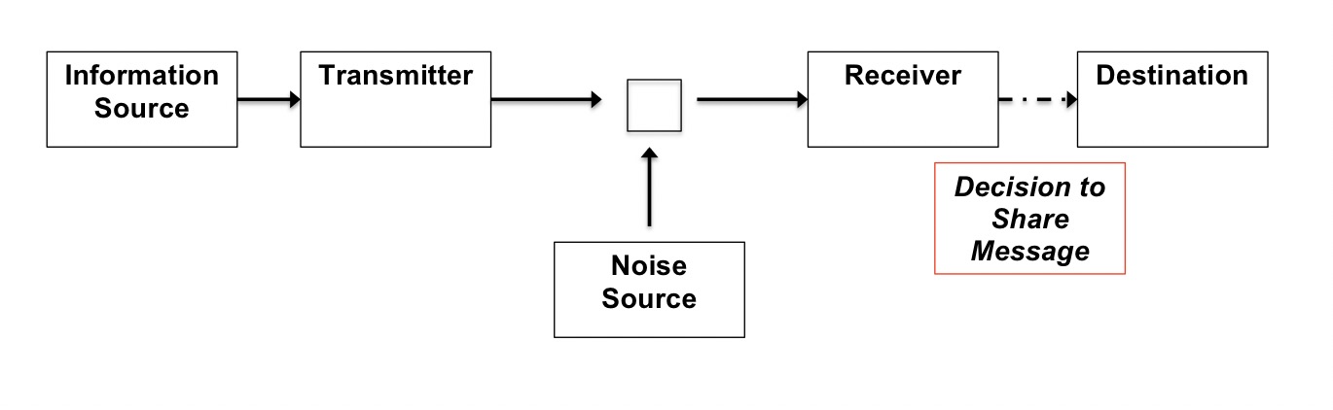

Figure 2: [COLOR]
File name: Figure2_DCE
Caption: English translations with all HIV advertisements considered throughout the choice exercise.
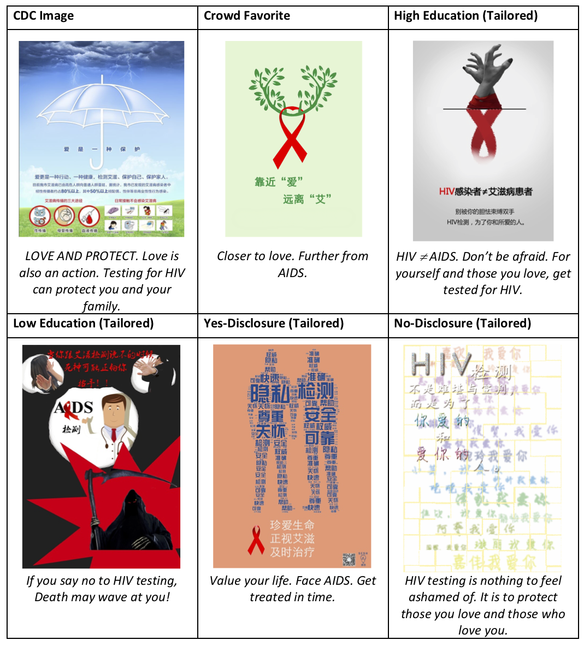

Figure 3: [COLOR]

Choice Experiment Attributes & Levels

Attributes | Levels
HIV Testing Image | CDC Image  [1] | Crowd Favorite  [2] |  | Education Image*  [3 or 4] |  | Disclosure Image*  [5 or 6]
Recipients | Entire Network |  | Select Network |  | Hand-Picked Group
Medium for Sharing | Sex-Seeking App (Grindr, Jack’d, BlueD) |  | Generic Social Networking Platforms (WeChat, WeiBo, QQ, etc.) |  | Generic Forum/ Blog
Originator of Image | Health Organization/  Health Professional |  | Social Media Contacts (Non-Sex Partners) |  | Sex Partners
* Tailored images

Caption: All attributes and levels used to construct choice tasks, based on participant demographic characteristics.

Figure 4: [COLOR]
File name: Figure4_DCE
Caption: Sample choice task presented to participants

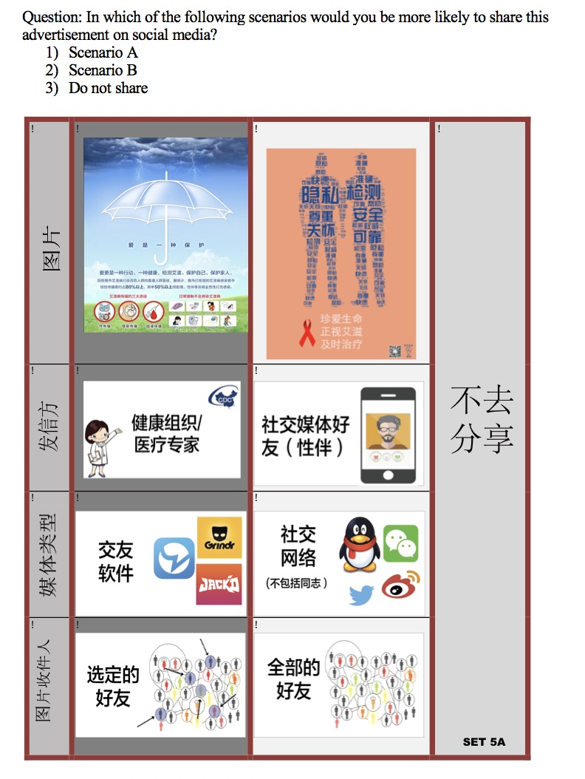

Figure 4: [COLOR]
File name: Figure5_DCE

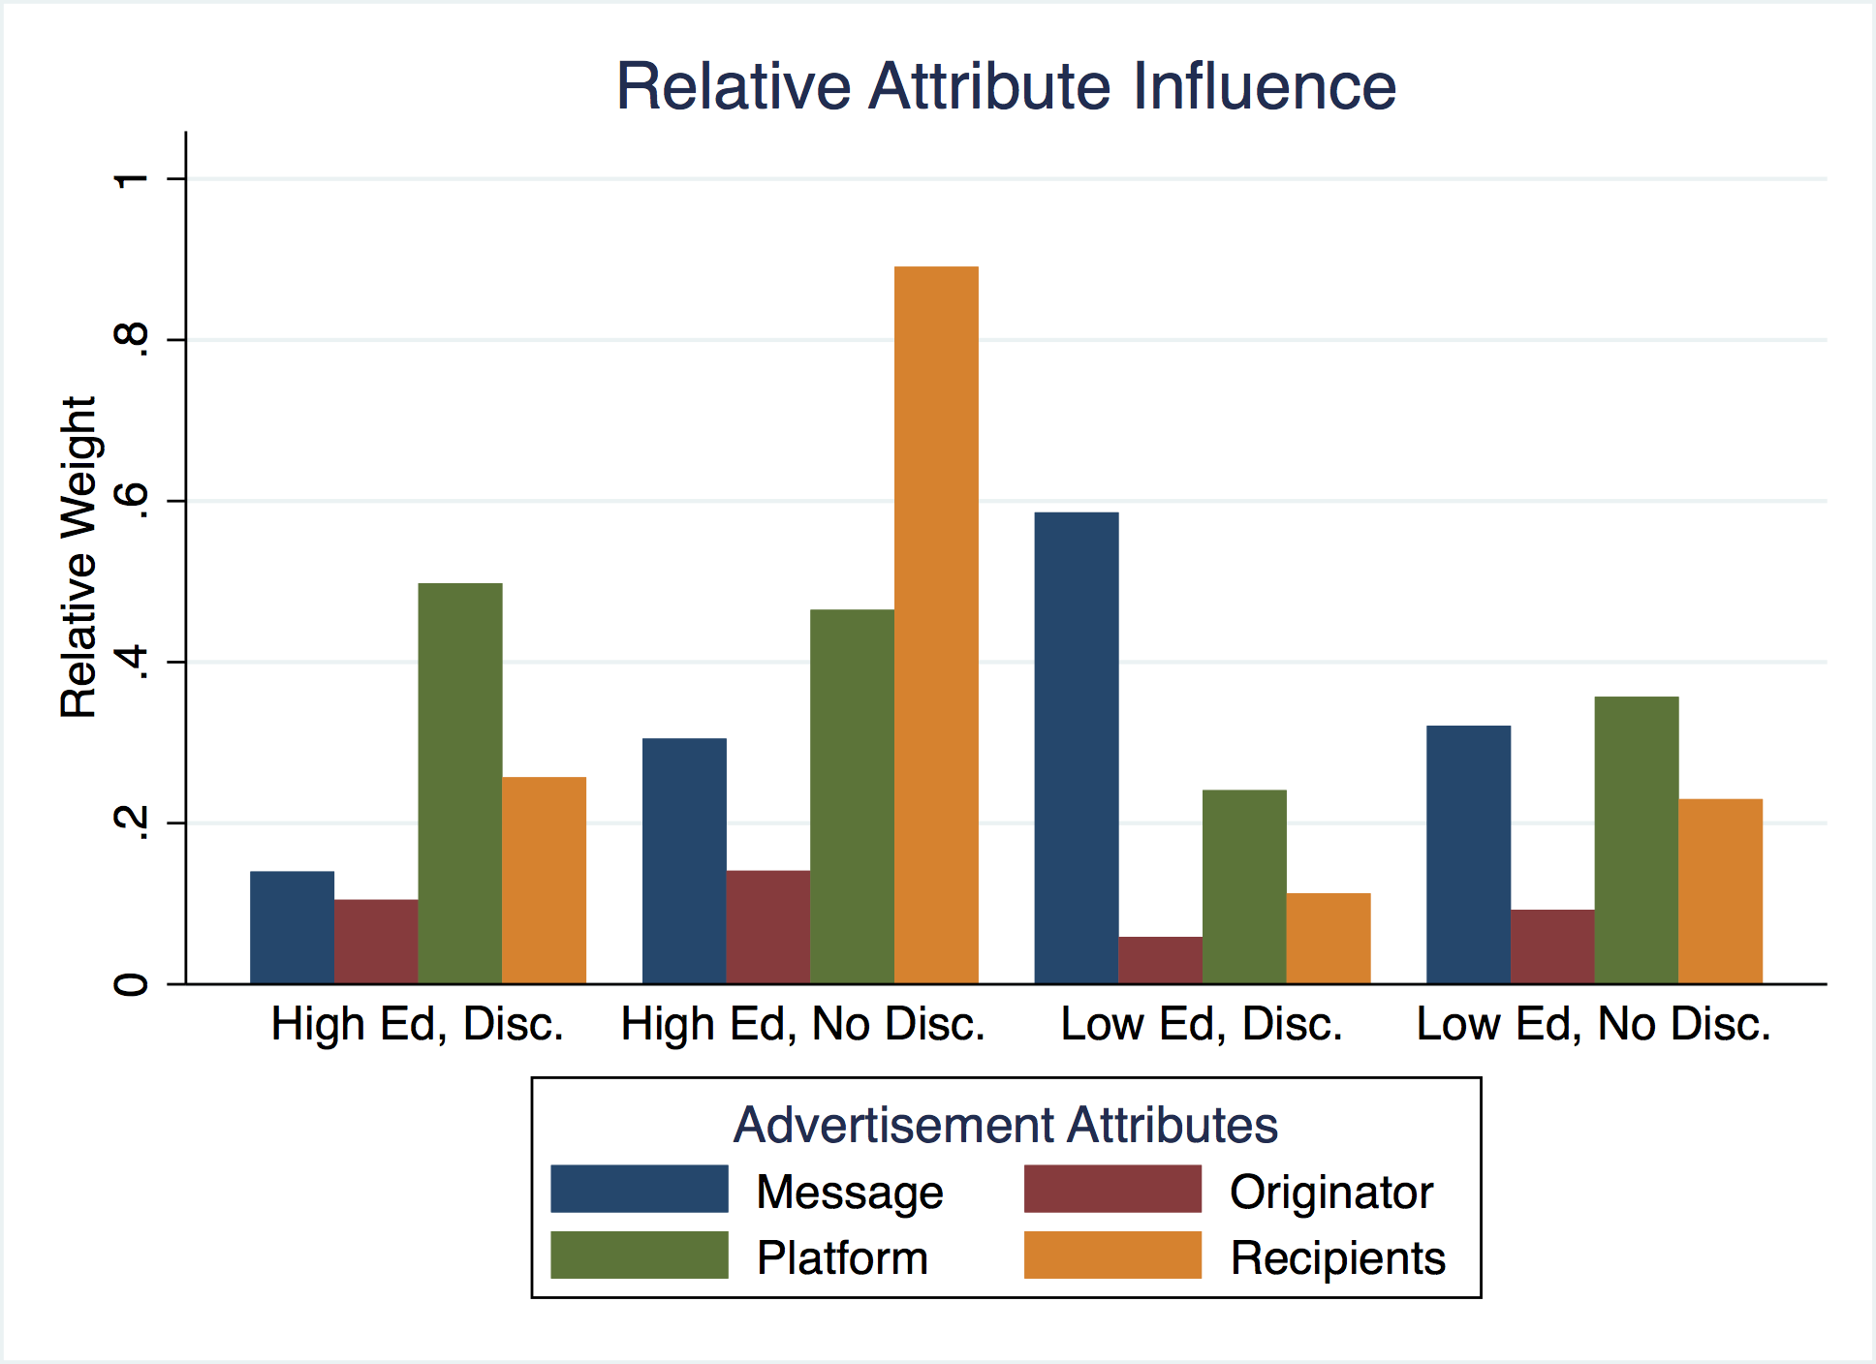

Caption: Relative attribute influence, stratified by subgroup (Chinese MSM, n = 854). Relative attribute influence, also reported in Table 3, was calculated using results from the multinomial logit model without interaction terms. Relative weights for each subgroup sum to 1, and bars indicate the average weight placed on each attribute by subgroup.

APPENDIX

Table A1: Multinomial Logit, Results (Chinese MSM: n = 854)
 | No Interactions |  |  |  | Interactions
 | High ed, Disc. | High ed, No Disc. | Low ed, Disc | Low ed, No Disc | High ed, Disc. | High ed, No Disc. | Low ed, Disc | Low ed, No Disc
Log likelihood | -2317.87 | -2268.94 | -1953.05 | -2063.11 | -2306.58 | -2258.99 | -1934.33 | -2052.99
Opt-Out | .520*** | .409*** | .503*** | .462 *** | .526 *** | .413 *** | .520 *** | .472***
 | (.035) | (.036) | (.039) | (.037) | (.036) | (.036) | (.039) | (.037)
Message
CDC | -.140* | -.136* | .171*** | .282 *** | -.144* | -.137* | .159* | .281 ***
 | (.078) | (.077) | (.082) | (.081) | (.079) | (.077) | (.083) | (.081)
Crowd favorite | -.005 | .209*** | .332*** | .207 *** | .006 | .206*** | .343*** | .211 ***
 | (.074) | (.073) | (.080) | (.080) | .074) | (.074) | (.081) | (.080)
Education message | .089 | .208** | -.662*** | -.389*** | .095 | .196** | -.665*** | -.390 ***
 | (.085) | (.085) | (.094) | (.089) | (.086) | (.086) | (.094) | (.089)
Disclosure message | -.056 | - .281*** | -.159 *** | -.100 ** | .043 | -.265*** | .163 | -.102 *
 | (.072) | (.069) | (.081) | (.083) | (.073) | (.077) | (.091) | (.086)
Originator
Medical Professional | .084 | .094 | .000 | .106 | -.002 | .382 | .445** | -.009
 | (.062) | (.064) | (.071) | (.066) | (.227) | (.243) | (.236) | (.221)
Friend | -.087 | -.133* | -.050 | -.088 | -.396* | -.523** | -.414** | -.197
 | (.069) | (.069) | (.073) | (.072) | (.234) | (.252) | (.231) | (.224)
Partner | .003 | .039 | .050 | -.018 | .398* | .141 | -.031 | .206
 | (.064) | (.063) | (.077) | (.068) | (.231) | (.250) | (.233) | (.222)
Medium
Social media (general) | -.433*** | -.330*** | -.041 | -.321*** | .018 | .123 | -.205 | -.278
 | (.062) | (.064) | (.069) | (.067) | (.233) | (.241) | (.227) | (.220)
Sex-seeking apps (MSM) | .382*** | .416*** | .225*** | .427*** | .127 | -.118 | -.259 | .772 ***
 | (.063) | (.067) | (.073) | (.068) | (.226) | (.249) | (.232) | (.224)
Blogs | .051 | -.086 | -.184 | -.106 * | -.145 | -.005 | .464 | -.494 **
 | (.061) | (.065) | (.070) | (.067) | (.224) | (.245) | (.231) | (.220)
Recipients
All | -.248*** | -.083 | -.114 | -.249*** | .187 | -.267 | -.060 | -.150
 | (.070) | (.067) | (.074) | (.072) | (.249) | (.258) | (.246) | (.233)
Small networks (10-12 people) | .173** | .023 | .036 | .233*** | .047 | .269 | -.205 | .186
 | (.062) | (.062) | (.066) | (.065) | (.221) | (.232) | (.214) | (.218)
Handful of friends (5-7 people) | .075 | .060 | .078 | .016 | -.234 | -.002 | .265 | -.036
 | (.064) | (.064) | (.071) | (.070) | (.231) | (.241) | (.221) | (.222)
Interactions: Recipients
All*Engagement |  |  |  |  | -.012 | .053 | -.015 | .006
 |  |  |  |  | (.040) | (.043) | (.040) | (.047)
Network*Engagement |  |  |  |  | .009 | -.018 | .043 | .019
 |  |  |  |  | (.035) | (.039) | (.037) | (.043)
All*SocialMediaUse |  |  |  |  | -.096* | .022 | .004 | -.075
 |  |  |  |  | (.035) | (.067) | (.066) | (.065)
Network*SocialMediaUse |  |  |  |  | .018 | -.072 | .057 | .012
 |  |  |  |  | (.050) | (.061) | (.057) | (.059)
All*Age |  |  |  |  | -.217 | .007 | -.023 | .201
 |  |  |  |  | (.137) | (.149) | (.167) | (.143)
Network*Age |  |  |  |  | .082 | .045(.138) | -.219 | -.032
 |  |  |  |  | (.125) |  | (.150) | (.132)
Interactions: Medium
SocialMedia*Engagement |  |  |  |  | -.021 | -.009 | .006 | -.044
 |  |  |  |  | (.037) | (.040) | (.037) | (.045)
App*Engagement |  |  |  |  | .019 | .034 | .074* | -.021
 |  |  |  |  | (.036) | (.041) | (.039) | (.045)
SocialMedia*SocialMediaUse |  |  |  |  | -.118** | -.141** | -.075 | -.009
 |  |  |  |  | (.052) | (.063) | (.061) | (.061)
App*SocialMediaUse |  |  |  |  | .073 | .127* | .156** | -.121 *
 |  |  |  |  | (.051) | (.065) | (.063) | (.061)
SocialMedia*Age |  |  |  |  | -.052 | .012 | .489*** | .122
 |  |  |  |  | (.129) | (.141) | (.158) | (.135)
App*Age |  |  |  |  | -.057 | .192 | -.291* | .082
 |  |  |  |  | (.127) | (.147) | (.161) | (.136)
Interactions: Originator
MedicalProvider*Engagement |  |  |  |  | -.022 | -.039 | -.002 | .035
 |  |  |  |  | (.036) | (.040) | (.038) | (.045)
Friend*Engagement |  |  |  |  | .072* | -.010 | -.009 | -.022
 |  |  |  |  | (.037) | (.042) | (.039) | (.045)
MedicalProvider*SocialMediaUse |  |  |  |  | .015 | -.037 | -.133** | .036
 |  |  |  |  | (.050) | (.063) | (.065) | (.061)
Friend*SocialMediaUse |  |  |  |  | .029 | .110* | .044 | .009
 |  |  |  |  | (.053) | (.067) | (.061) | (.062)
MedicalProvider*Age |  |  |  |  | .259** | -.243* | .012 | -.086
 |  |  |  |  | (.126) | (.143) | (.162) | (.135)
Friend*Age |  |  |  |  | -.056 | .228 | .394** | .235 *
 |  |  |  |  | (.131) | (.148) | (.164) | (.137)
Standard errors reported in parentheses, * p < .1, ** p < .05, *** p < .01

Table A2: Likelihood of “Opting Out” of a Choice Task - Chinese MSM, n = 854
 | Disclosed sexual history | High education | Identify as gay | Community engagement index | Social media use index | Social Media: never comment | Social Media: never post
Full Sample | OR = .699 | OR = 1.00 | OR = 1.14 | OR = .791 | OR = .890 | OR = 1.29 | OR = 1.62
 | (.64 - .77) | (.92 - 1.10) | (1.02 - 1.28) | (.77 - .81) | (.86 - .93) | (1.16-1.44) | (1.39-1.87)
High Ed, Disc. |  |  | OR = .78 | OR = .75 | OR = 1.04 | OR = .81 | OR = 1.58
 |  |  | (.61 - .10) | (.71 - .80) | (.96 - 1.12) | (.62 - 1.05) | (1.15 - 2.18)
High Ed, No Disc. |  |  | OR = .88 | OR = .85 | OR = 1.04 | OR = .82 | OR = 1.03
 |  |  | (.73 - 1.07) | (.80 - .90) | (.97 - 1.13) | (.66 - 1.03) | (.72 - 1.46)
Low Ed, Disc. |  |  | OR = 1.20 | OR = .77 | OR = .804 | OR = 2.06 | OR = 3.49
 |  |  | (.92 - 1.55) | (.73 - .81) | (.74 - .88) | (1.67 - 2.55) | (2.69 - 4.53)
Low Ed, No Disc. |  |  | OR = 2.28 | OR = .81 | OR = .66 | OR = 1.93 | OR = 1.06
 |  |  | (1.80 - 2.89) | (.76 - .87) | (.61 - .72) | (1.56 - 2.39) | (.78 - 1.44)
Note: Odds ratios given, 95 percent confidence intervals in parentheses. Results from a multinomial logistic regression.

